ANDROID TUTORIAL

TEAM-13 (TEAM MEMBERS):
ADVAITA MANOHAR (Roll no: 54)
ALFIN WILLIAM (Roll no: 55)
GOKUL K (Roll no: 19)
GOPIKA PRATHEEP (Roll no: 20)

1. We have to create linear layout which contains one button and a text view. In button tag we set the button_id as@id/button. This id is used to uniquely identify the view. When we click on button, the text view text will change to ‘you have clicked the button’.

1. GOPIKA PRADEEP ( 29/03/19)
2. ALFIN WILLIAM ( 29/03/19)
3. ADVAITA MANOHAR ( 29/03/19)
4. GOKUL K ( 29/03/19)

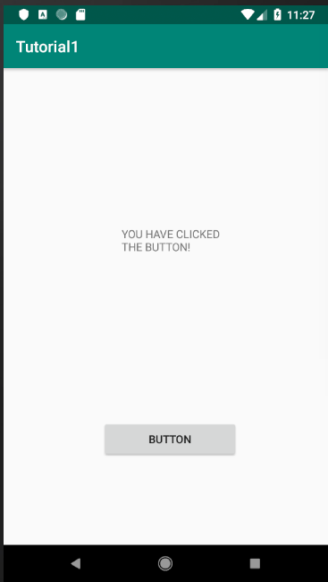
Screenshots:

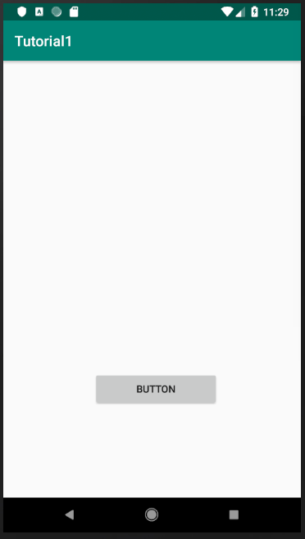

activty_main.xml

<LinearLayout xmlns:android="http://schemas.android.com/apk/res/android"
xmlns:app="http://schemas.android.com/apk/res-auto"
xmlns:tools="http://schemas.android.com/tools"
android:layout_width="match_parent"
android:layout_height="match_parent"
android:orientation="vertical"
tools:context=".MainActivity">
<TextView
android:id="@+id/tv1"
android:layout_width="132dp"
android:layout_height="wrap_content"
android:layout_marginLeft="150dp"
android:layout_marginTop="200dp"
android:text=""
/>
<Button
android:id="@+id/button"
android:layout_width="173dp"
android:text="BUTTON"
android:layout_height="wrap_content"
android:layout_marginLeft="125dp"
android:layout_marginTop="210dp" />
</LinearLayout>

MainActivity.java

package com.example.tutorial1;
import android.support.v7.app.AppCompatActivity;
import android.os.Bundle;
import android.view.View;
import android.widget.Button;
import android.widget.TextView;
public class MainActivity extends AppCompatActivity {
Button button;
TextView textView;
@Override
protected void onCreate(Bundle savedInstanceState) {
super.onCreate(savedInstanceState);
setContentView(R.layout.activity_main);
button=(Button)findViewById(R.id.button);
textView=(TextView)findViewById(R.id.tv1);
button.setOnClickListener(new View.OnClickListener() {
@Override
public void onClick(View v) {
textView.setText("YOU HAVE CLICKED THE BUTTON!");
}
});
}
}

2. We have to create three check boxes named as INDIA, SRILANKA and PAKISTAN. When we check the specific checkbox,it will display the corresponding text of that checkbox in the textview.

1. GOPIKA PRADEEP ( 29/03/19)
2. ALFIN WILLIAM ( 29/03/19)
3. ADVAITA MANOHAR ( 29/03/19)
4. GOKUL K ( 29/03/19)

Screenshots:

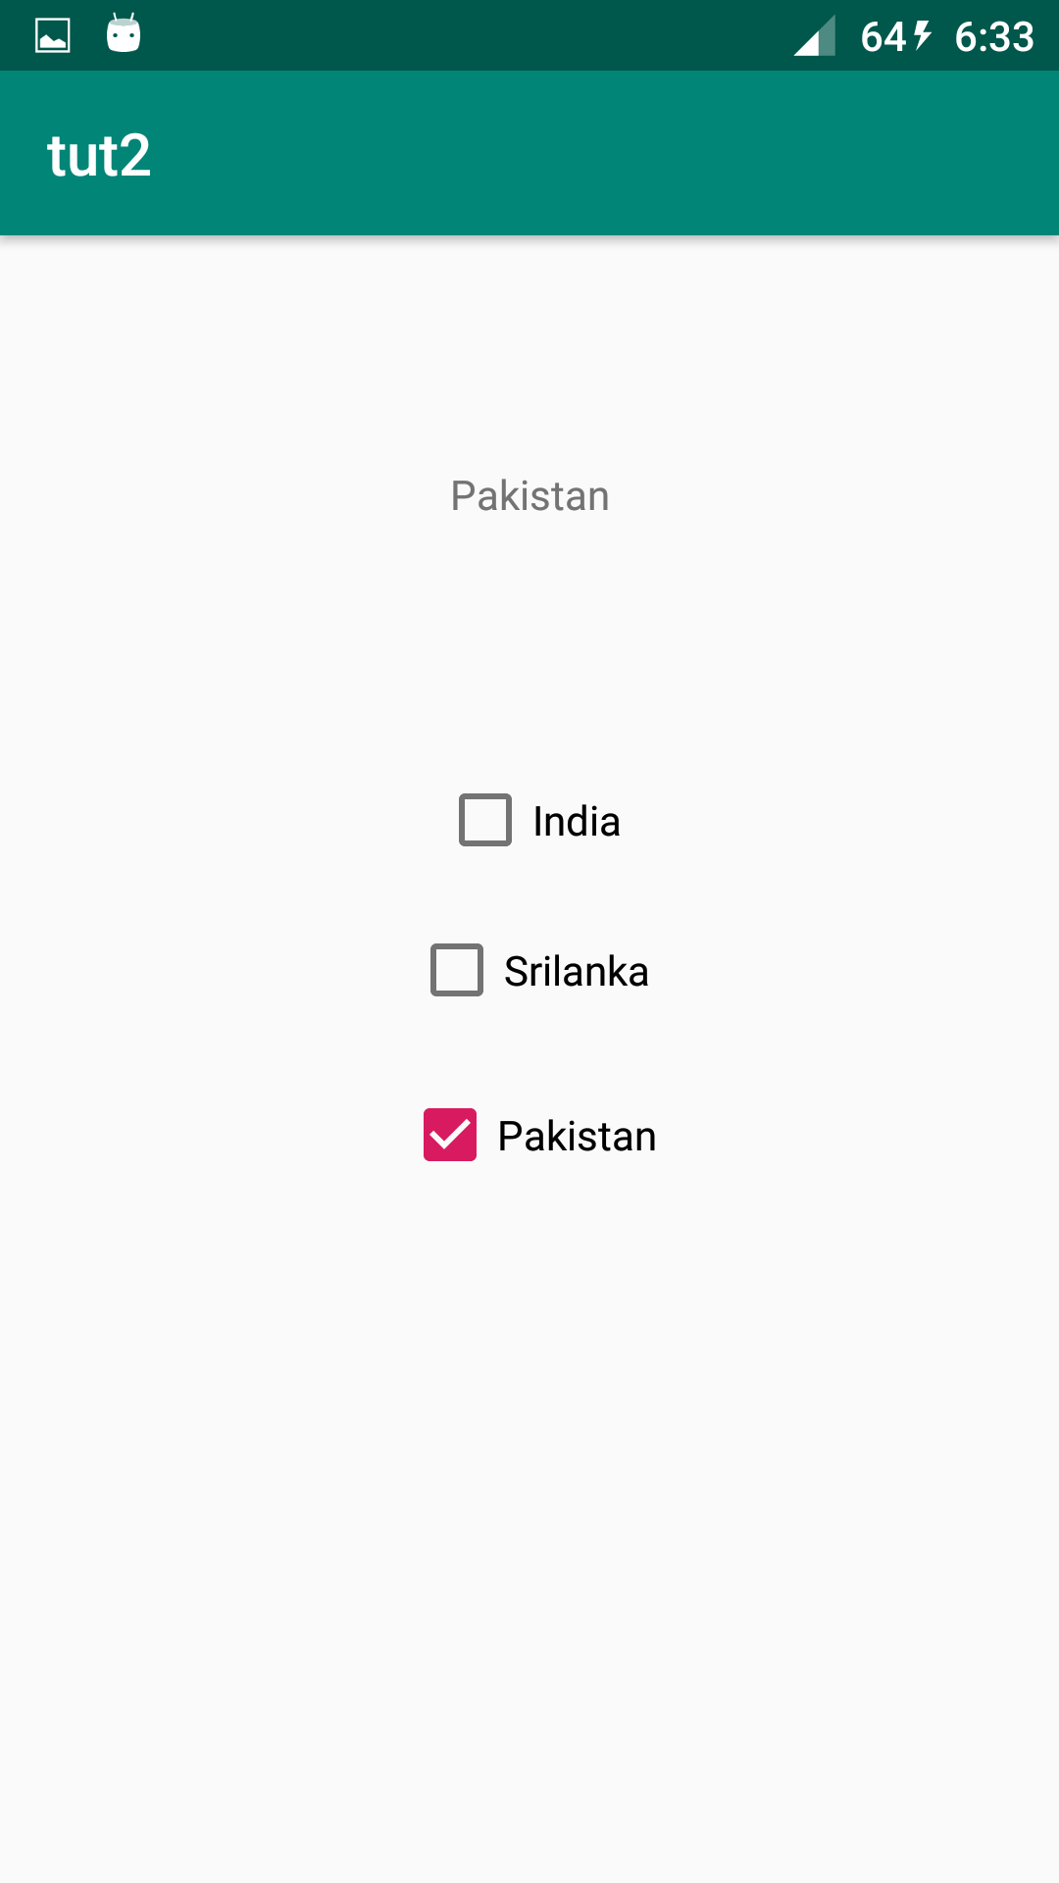
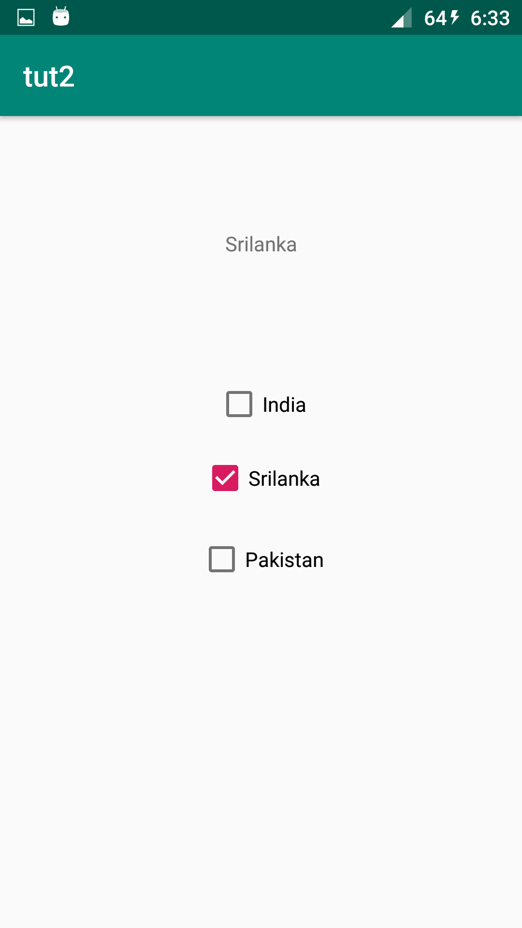

MainActivity.java

package com.example.warlock.tut2;
import android.support.v7.app.AppCompatActivity;
import android.os.Bundle;
import android.view.View;
import android.widget.CheckBox;
import android.widget.TextView;
public class MainActivity extends AppCompatActivity {
@Override
protected void onCreate(Bundle savedInstanceState) {
super.onCreate(savedInstanceState);
setContentView(R.layout.activity_main);
}
public void sri(View view)
{
TextView et = findViewById(R.id.textView);
CheckBox b=findViewById(R.id.checkedTextView3);
if(b.isChecked())
et.setText("Srilanka");
}
public void pak(View view)
{
TextView et= findViewById(R.id.textView);
CheckBox b=findViewById(R.id.checkedTextView);
if(b.isChecked())
et.setText("Pakistan");
}public void India(View view)
{
TextView et= findViewById(R.id.textView);
CheckBox b=findViewById(R.id.checkedTextView2);
if(b.isChecked())
et.setText("India");
}
}

activity_main.xml

<?xml version="1.0" encoding="utf-8"?>
<android.support.constraint.ConstraintLayout xmlns:android="http://schemas.android.com/apk/res/android"
xmlns:app="http://schemas.android.com/apk/res-auto"
xmlns:tools="http://schemas.android.com/tools"
android:layout_width="match_parent"
android:layout_height="match_parent"
tools:context="com.example.warlock.tut2.MainActivity">
<CheckBox
android:id="@+id/checkedTextView"
android:layout_width="wrap_content"
android:layout_height="wrap_content"
android:layout_marginBottom="8dp"
android:layout_marginEnd="8dp"
android:layout_marginStart="8dp"
android:layout_marginTop="8dp"
android:text="Pakistan"
app:layout_constraintBottom_toBottomOf="parent"
app:layout_constraintEnd_toEndOf="parent"
app:layout_constraintStart_toStartOf="parent"
app:layout_constraintTop_toTopOf="parent"
app:layout_constraintVertical_bias="0.55"
android:onClick="pak"/>
<CheckBox
android:id="@+id/checkedTextView2"
android:layout_width="wrap_content"
android:layout_height="wrap_content"
android:layout_marginBottom="8dp"
android:layout_marginEnd="8dp"
android:layout_marginStart="8dp"
android:layout_marginTop="8dp"
android:text="India"
app:layout_constraintBottom_toBottomOf="parent"
app:layout_constraintEnd_toEndOf="parent"
app:layout_constraintHorizontal_bias="0.501"
app:layout_constraintStart_toStartOf="parent"
app:layout_constraintTop_toTopOf="parent"
app:layout_constraintVertical_bias="0.341"
android:onClick="India"/>
<CheckBox
android:id="@+id/checkedTextView3"
android:layout_width="wrap_content"
android:layout_height="wrap_content"
android:layout_marginBottom="8dp"
android:layout_marginEnd="8dp"
android:layout_marginStart="8dp"
android:layout_marginTop="8dp"
android:text="Srilanka"
app:layout_constraintBottom_toBottomOf="parent"
app:layout_constraintEnd_toEndOf="parent"
app:layout_constraintStart_toStartOf="parent"
app:layout_constraintTop_toTopOf="parent"
app:layout_constraintVertical_bias="0.441"
android:onClick="sri"
/>
<TextView
android:id="@+id/textView"
android:layout_width="wrap_content"
android:layout_height="wrap_content"
android:layout_marginBottom="8dp"
android:layout_marginEnd="8dp"
android:layout_marginStart="8dp"
android:layout_marginTop="8dp"
app:layout_constraintBottom_toBottomOf="parent"
app:layout_constraintEnd_toEndOf="parent"
app:layout_constraintStart_toStartOf="parent"
app:layout_constraintTop_toTopOf="parent"
app:layout_constraintVertical_bias="0.134"
/>
</android.support.constraint.ConstraintLayout>

3. We have to create three check boxes named as INDIA, SRILANKA and PAKISTAN. When we check one or more boxes,it will display the f those check box in the edittext.

1. GOPIKA PRADEEP ( 29/03/19)
2. ALFIN WILLIAM ( 29/03/19)
3. ADVAITA MANOHAR ( 29/03/19)
4. GOKUL K ( 29/03/19)

Screenshots:

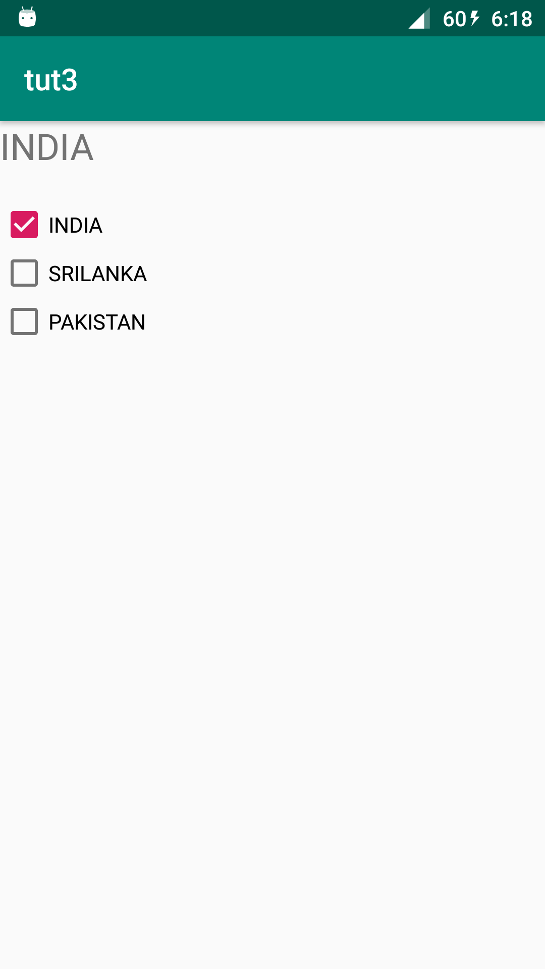
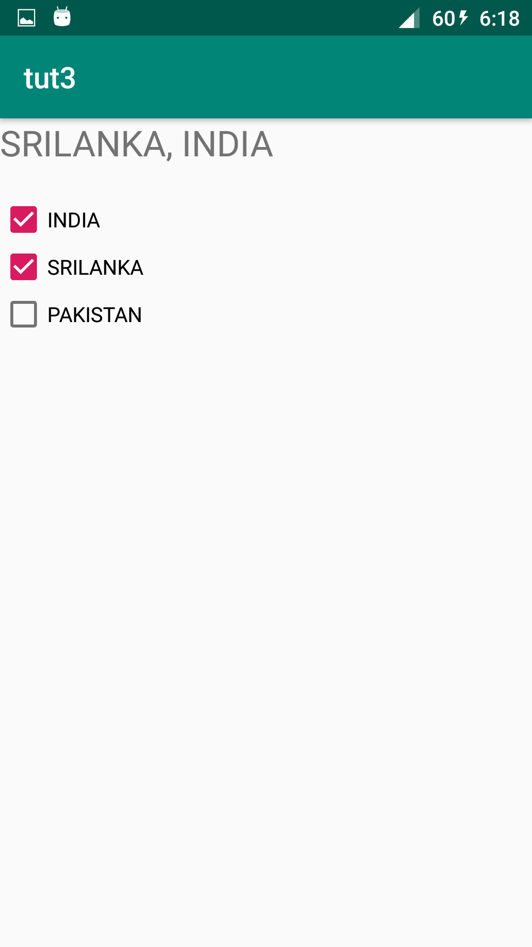

Main_Activity.java

package com.example.warlock.tut3;
import android.support.v7.app.AppCompatActivity;
import android.os.Bundle;
import android.util.Log;
import android.widget.CheckBox;
import android.widget.CompoundButton;
import android.widget.TextView;
import java.io.Console;
import java.util.HashSet;
public class MainActivity extends AppCompatActivity {
HashSet<String> hash = new HashSet<>();
@Override
protected void onCreate(Bundle savedInstanceState) {
super.onCreate(savedInstanceState);
setContentView(R.layout.activity_main);
final TextView tv = findViewById(R.id.text);
final CheckBox chk1 = findViewById(R.id.checkBox1);
final CheckBox chk2 = findViewById(R.id.checkBox2);
final CheckBox chk3 = findViewById(R.id.checkBox3);
chk1.setOnCheckedChangeListener(new CompoundButton.OnCheckedChangeListener() {
@Override
public void onCheckedChanged(CompoundButton buttonView, boolean isChecked) {
if (isChecked) {
hash.add(chk1.getText().toString());
changeText(tv);
} else {
hash.remove(chk1.getText().toString());
changeText(tv);
}
}
});
chk2.setOnCheckedChangeListener(new CompoundButton.OnCheckedChangeListener() {
@Override
public void onCheckedChanged(CompoundButton buttonView, boolean isChecked) {
if (isChecked) {
hash.add(chk2.getText().toString());
changeText(tv);
} else {
hash.remove(chk2.getText().toString());
changeText(tv);
}
}
});
chk3.setOnCheckedChangeListener(new CompoundButton.OnCheckedChangeListener() {
@Override
public void onCheckedChanged(CompoundButton buttonView, boolean isChecked) {
if (isChecked) {
hash.add(chk3.getText().toString());
changeText(tv);
} else {
hash.remove(chk3.getText().toString());
changeText(tv);
}
}
});
}
private void changeText(TextView tv) {
tv.setText(hash.toString().replace("[", "").replace("]", ""));
}
}

Activity_main.xml

<?xml version="1.0" encoding="utf-8"?>
<android.support.constraint.ConstraintLayout xmlns:android="http://schemas.android.com/apk/res/android"
xmlns:app="http://schemas.android.com/apk/res-auto"
xmlns:tools="http://schemas.android.com/tools"
android:layout_width="match_parent"
android:layout_height="match_parent"
tools:context=".MainActivity">
<LinearLayout
android:layout_width="match_parent"
android:layout_height="match_parent"
android:orientation="vertical">
<TextView
android:id="@+id/text"
android:layout_width="match_parent"
android:layout_height="wrap_content"
android:layout_marginBottom="20dp"
android:textSize="24sp" />
<LinearLayout
android:layout_width="match_parent"
android:layout_height="match_parent"
android:orientation="vertical">
<CheckBox
android:id="@+id/checkBox1"
android:layout_width="match_parent"
android:layout_height="wrap_content"
android:text="INDIA" />
<CheckBox
android:id="@+id/checkBox2"
android:layout_width="match_parent"
android:layout_height="wrap_content"
android:text="SRILANKA" />
<CheckBox
android:id="@+id/checkBox3"
android:layout_width="match_parent"
android:layout_height="wrap_content"
android:text="PAKISTAN" />
</LinearLayout>
</LinearLayout>
</android.support.constraint.ConstraintLayout>

4. Create an application contains two toggle button and one button .When we click on toggle button it will show a toast message.
1. GOPIKA PRADEEP ( 12/04/19)
2. ALFIN WILLIAM ( 05/04/19)
3. ADVAITA MANOHAR ( 12/04/19)
4. GOKUL K ( 05/04/19)

Screenshots:

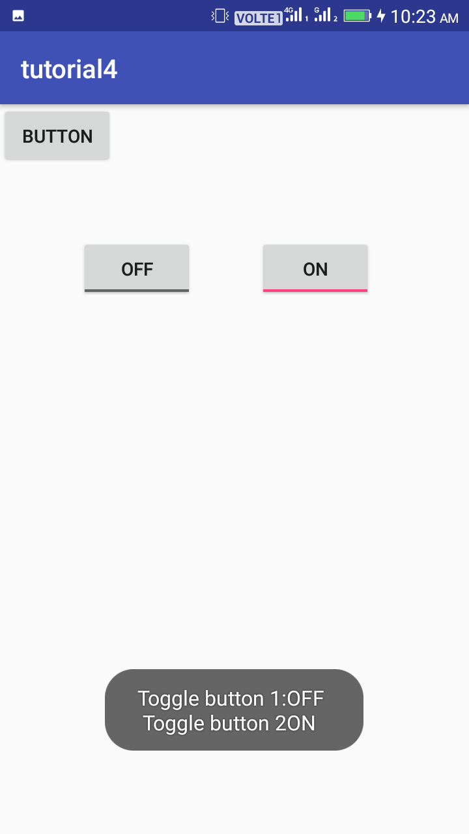

Main_Activity.java
package com.example.tutorial3;
import android.support.v7.app.AppCompatActivity;
import android.os.Bundle;
import android.view.View;
import android.widget.Toast;
import android.widget.ToggleButton;
public class MainActivity extends AppCompatActivity {
@Override
protected void onCreate(Bundle savedInstanceState) {
super.onCreate(savedInstanceState);
setContentView(R.layout.activity_main);
}
public void show(View view)
{
ToggleButton tb= findViewById(R.id.toggleButton);
ToggleButton tb1=findViewById(R.id.toggleButton2);
Toast.makeText(this,"Toggle button 1:"+tb.getText().toString()+"\n Toggle button 2"+tb1.getText().toString(), Toast.LENGTH_SHORT).show();
}
}

Activity_main.xml

<?xml version="1.0" encoding="utf-8"?>
<android.support.constraint.ConstraintLayout xmlns:android="http://schemas.android.com/apk/res/android"
xmlns:app="http://schemas.android.com/apk/res-auto"
xmlns:tools="http://schemas.android.com/tools"
android:layout_width="match_parent"
android:layout_height="match_parent"
tools:context="com.example.andlaba.tutorial4.MainActivity">
<ToggleButton
android:id="@+id/toggleButton"
android:layout_width="wrap_content"
android:layout_height="wrap_content"
android:layout_marginBottom="8dp"
android:layout_marginEnd="8dp"
android:layout_marginStart="8dp"
android:layout_marginTop="8dp"
android:text="ToggleButton"
app:layout_constraintBottom_toBottomOf="parent"
app:layout_constraintEnd_toEndOf="parent"
app:layout_constraintHorizontal_bias="0.207"
app:layout_constraintStart_toStartOf="parent"
app:layout_constraintTop_toTopOf="parent"
app:layout_constraintVertical_bias="0.19" />
<ToggleButton
android:id="@+id/toggleButton2"
android:layout_width="wrap_content"
android:layout_height="wrap_content"
android:layout_marginBottom="8dp"
android:layout_marginEnd="8dp"
android:layout_marginStart="8dp"
android:layout_marginTop="8dp"
android:text="ToggleButton"
app:layout_constraintBottom_toBottomOf="parent"
app:layout_constraintEnd_toEndOf="parent"
app:layout_constraintHorizontal_bias="0.742"
app:layout_constraintStart_toStartOf="parent"
app:layout_constraintTop_toTopOf="parent"
app:layout_constraintVertical_bias="0.19" />
<Button
android:id="@+id/button"
android:layout_width="wrap_content"
android:layout_height="wrap_content"
android:text="Button"
android:onClick="show"
tools:layout_editor_absoluteX="139dp"
tools:layout_editor_absoluteY="296dp" />
</android.support.constraint.ConstraintLayout>

5. Create an application which contains two radio button present in one group. That means at a time one radio button is selected .When we click on button, corresponding text will display in textview. That means, when we click on female radio button, it displays “selected gender:female”

1. GOPIKA PRADEEP ( 12/04/19)
2. ALFIN WILLIAM ( 05/04/19)
3. ADVAITA MANOHAR ( 12/04/19)
4. GOKUL K ( 05/04/19)

Screenshots:
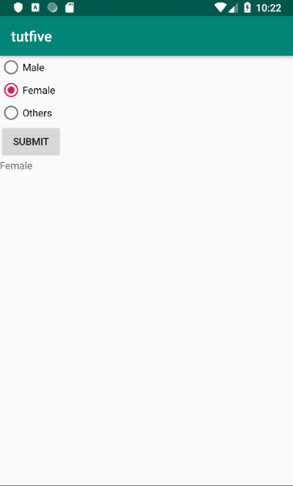
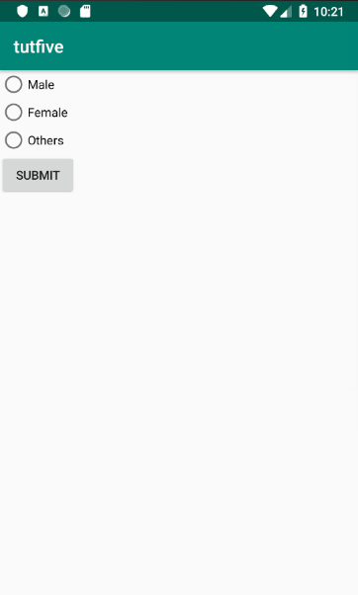

Main_Activity.java

package com.example.tutfive;
import android.support.v7.app.AppCompatActivity;
import android.os.Bundle;
import android.view.View;
import android.widget.Button;
import android.widget.RadioButton;
import android.widget.RadioGroup;
import android.widget.TextView;
import android.widget.Toast;
public class MainActivity extends AppCompatActivity {
RadioGroup gendrg;
RadioButton radiosexbutton;
Button submit;
TextView result;
@Override
protected void onCreate(Bundle savedInstanceState) {
super.onCreate(savedInstanceState);
setContentView(R.layout.activity_main);
gendrg=(RadioGroup) findViewById(R.id.grp);
submit=(Button) findViewById(R.id.submitbtn);
result=(TextView)findViewById(R.id.txtview);
submit.setOnClickListener(new View.OnClickListener() {
@Override
public void onClick(View v) {
int selectedid=gendrg.getCheckedRadioButtonId();
radiosexbutton=(RadioButton)findViewById(selectedid);
String gender=radiosexbutton.getText().toString();
result.setText(gender);
}
});
}
}

Activity_main.xml

<?xml version="1.0" encoding="utf-8"?>
<LinearLayout xmlns:android="http://schemas.android.com/apk/res/android"
xmlns:app="http://schemas.android.com/apk/res-auto"
xmlns:tools="http://schemas.android.com/tools"
android:layout_width="match_parent"
android:layout_height="match_parent"
android:orientation="vertical"
tools:context=".MainActivity">
<RadioGroup
android:id="@+id/grp"
android:layout_width="wrap_content"
android:layout_height="wrap_content">
<RadioButton
android:id="@+id/male"
android:layout_width="wrap_content"
android:layout_height="wrap_content"
android:text="Male" />
<RadioButton
android:id="@+id/female"
android:layout_width="wrap_content"
android:layout_height="wrap_content"
android:text="Female" />
<RadioButton
android:id="@+id/others"
android:layout_width="wrap_content"
android:layout_height="wrap_content"
android:text="Others" />
</RadioGroup>
<Button
android:id="@+id/submitbtn"
android:layout_width="wrap_content"
android:layout_height="wrap_content"
android:text="Submit" />
<TextView
android:id="@+id/txtview"
android:layout_width="wrap_content"
android:layout_height="wrap_content" />
</LinearLayout>

6. Create an example applcation , when we write a letter it suggests the words related to that letter which we write in the edit text.(Auto complete view)
1. GOPIKA PRADEEP ( 12/04/19)
2. ALFIN WILLIAM ( 05/04/19)
3. ADVAITA MANOHAR ( 12/04/19)
4. GOKUL K ( 05/04/19)

Screenshots:
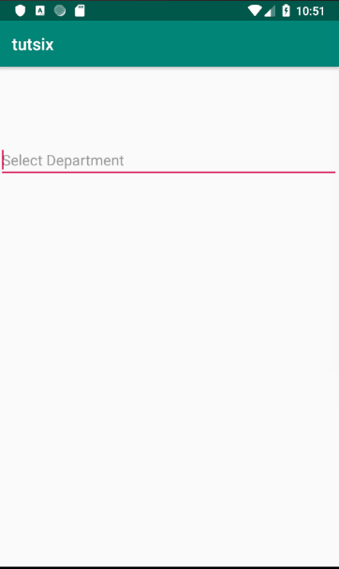
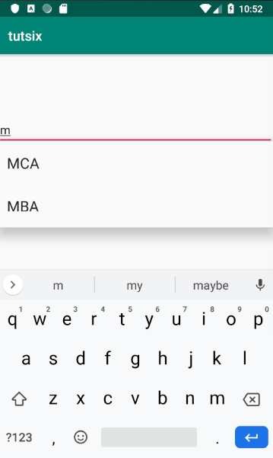

Main_Activity.java

package com.example.tutsix;
import android.support.v7.app.AppCompatActivity;
import android.os.Bundle;
import android.widget.ArrayAdapter;
import android.widget.AutoCompleteTextView;
public class MainActivity extends AppCompatActivity {
AutoCompleteTextView dpt;
String[] arr = { "MCA" , "MBA" ,"BTech"};
@Override
protected void onCreate(Bundle savedInstanceState) {
super.onCreate(savedInstanceState);
setContentView(R.layout.activity_main);
dpt= (AutoCompleteTextView) findViewById(R.id.autoCompleteTextView);
ArrayAdapter<String> adapter = new ArrayAdapter<String> (this,android.R.layout.select_dialog_item,arr);
dpt.setThreshold(1);
dpt.setAdapter(adapter);
}
}

Activity_main.xml

<?xml version="1.0" encoding="utf-8"?>
<LinearLayout xmlns:android="http://schemas.android.com/apk/res/android"
xmlns:app="http://schemas.android.com/apk/res-auto"
xmlns:tools="http://schemas.android.com/tools"
android:layout_width="match_parent"
android:layout_height="match_parent"
tools:context=".MainActivity">
<AutoCompleteTextView
android:id="@+id/autoCompleteTextView"
android:layout_width="wrap_content"
android:layout_height="wrap_content"
android:layout_weight="1"
android:paddingTop="100dp"
android:hint="Select Department"/>
</LinearLayout>

7. Create an example application, where we have to display one image on the screen. Then we have to create two images named android1 and android2,and place it in drawable folder .When we click on change button, the picture of image view will change to android2 (Image view)
1. GOPIKA PRADEEP ( 12/04/19)
2. ALFIN WILLIAM ( 05/04/19)
3. ADVAITA MANOHAR ( 12/04/19)
4. GOKUL K ( 05/04/19)

Screenshots:

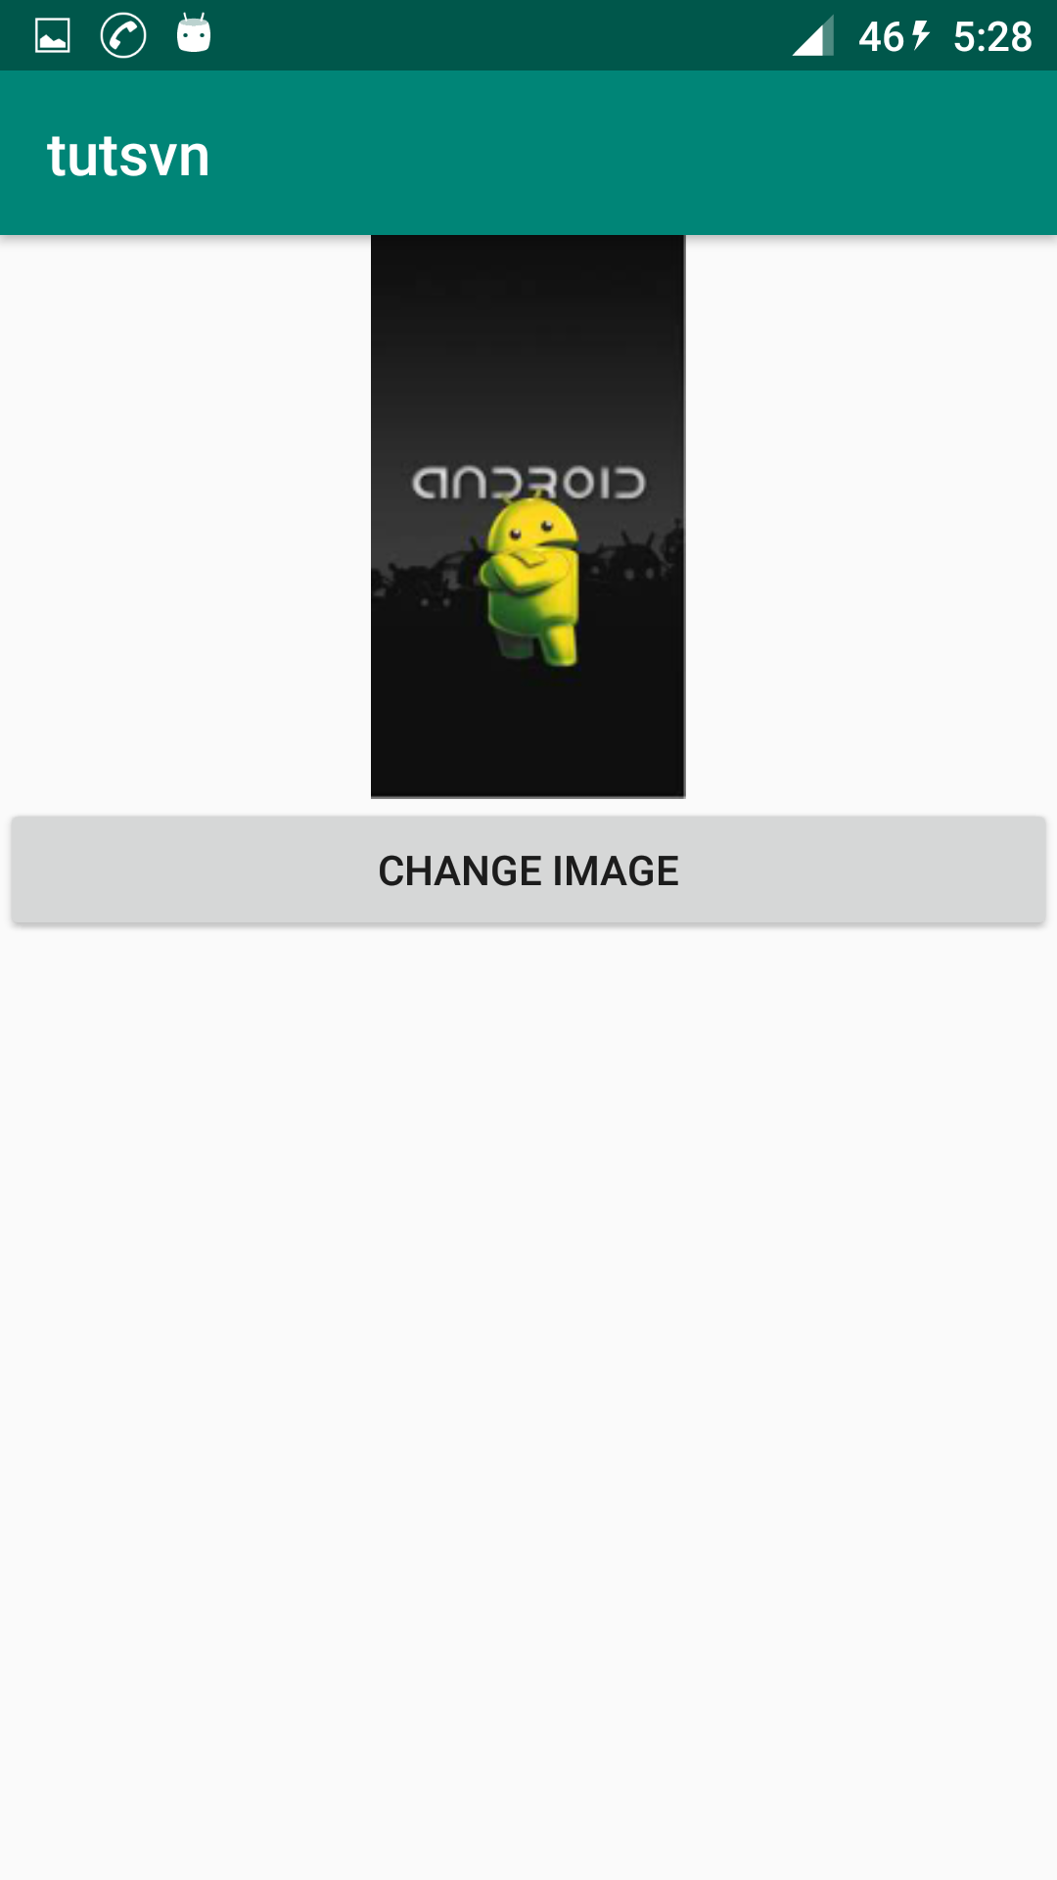
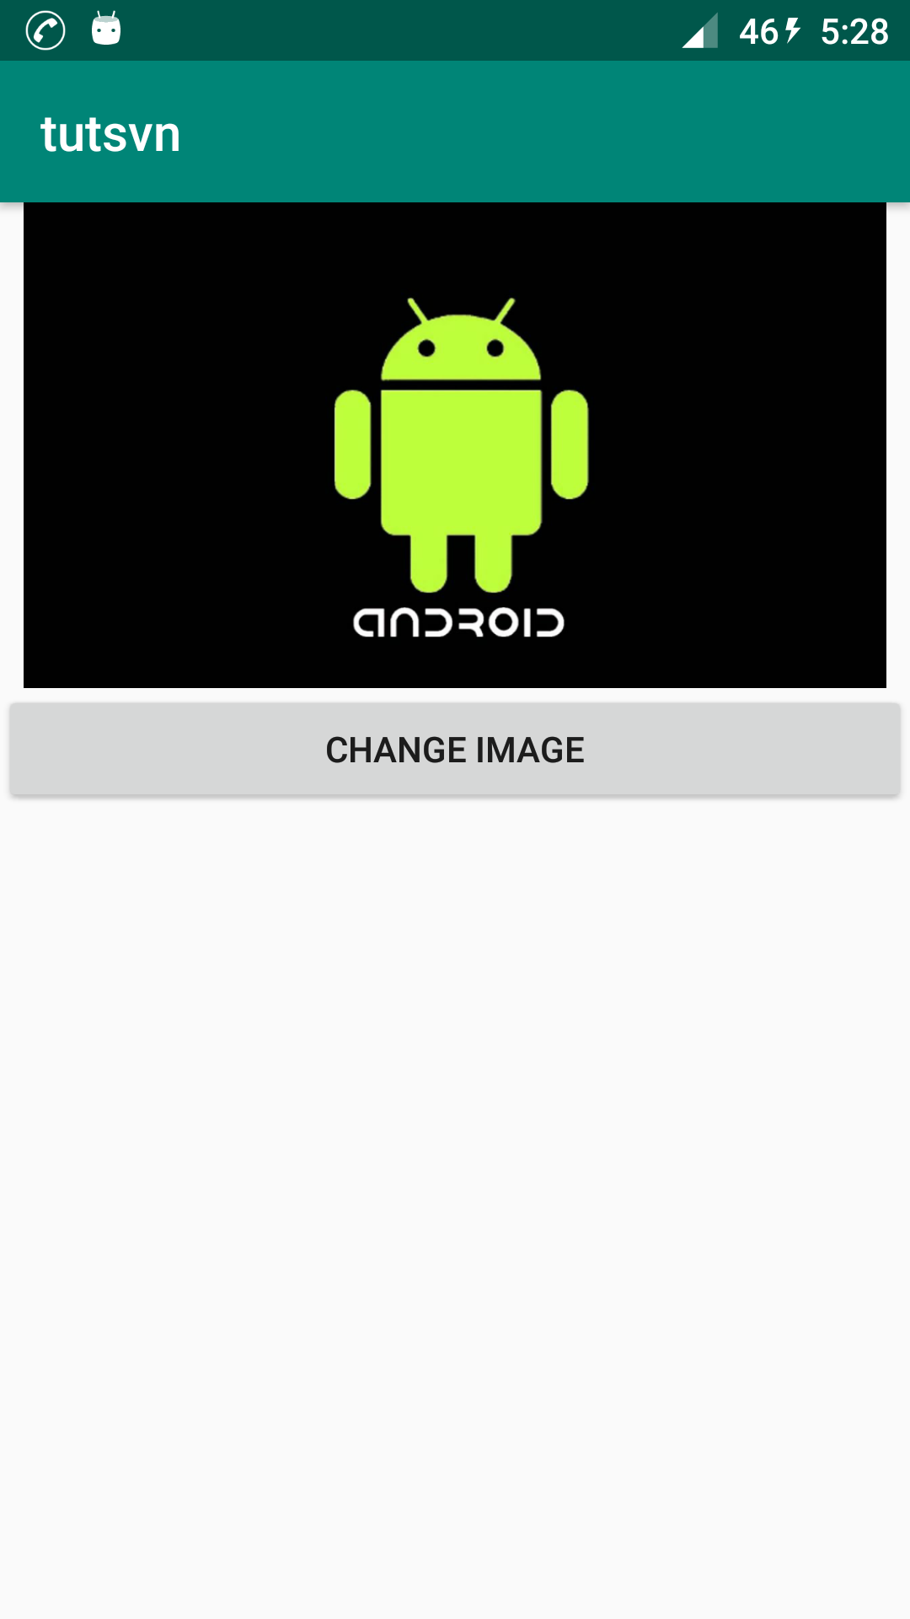

Main_Activity.java
package com.example.warlock.tutsvn;
import android.support.v7.app.AppCompatActivity;
import android.os.Bundle;
import android.view.View;
import android.widget.Button;
import android.widget.ImageView;
public class MainActivity extends AppCompatActivity {
ImageView img;
Button btn;
@Override
protected void onCreate(Bundle savedInstanceState) {
super.onCreate(savedInstanceState);
setContentView(R.layout.activity_main);
btn=(Button)findViewById(R.id.button);
img=(ImageView)findViewById(R.id.img);
btn.setOnClickListener(new View.OnClickListener() {
@Override
public void onClick(View v) {
img.setImageResource(R.drawable.and2);
}
});
}
}

Activity_main.xml

<?xml version="1.0" encoding="utf-8"?>
<LinearLayout xmlns:android="http://schemas.android.com/apk/res/android"
xmlns:app="http://schemas.android.com/apk/res-auto"
xmlns:tools="http://schemas.android.com/tools"
android:layout_width="match_parent"
android:layout_height="match_parent"
android:orientation="vertical"
tools:context=".MainActivity">
<ImageView
android:id="@+id/img"
android:layout_width="match_parent"
android:layout_height="@android:dimen/thumbnail_height"
android:src="@drawable/and1" />
<Button
android:id="@+id/button"
android:layout_width="match_parent"
android:layout_height="wrap_content"
android:text="Change Image" />
</LinearLayout>

8. Create an example ,where you have a push button for which you can specify a customized background image (Drawable)
1. GOPIKA PRADEEP ( 12/04/19)
2. ALFIN WILLIAM ( 05/04/19)
3. ADVAITA MANOHAR ( 12/04/19)
4. GOKUL K ( 05/04/19)

Screenshots:
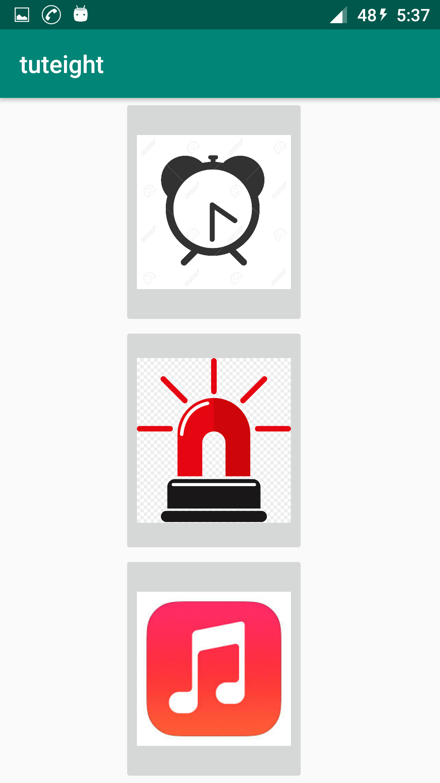

Main_Activity.java

package com.example.warlock.tuteight;
import android.support.v7.app.AppCompatActivity;
import android.os.Bundle;
public class MainActivity extends AppCompatActivity {
@Override
protected void onCreate(Bundle savedInstanceState) {
super.onCreate(savedInstanceState);
setContentView(R.layout.activity_main);
}
}
Activity_main.xml
<?xml version="1.0" encoding="utf-8"?>
<LinearLayout xmlns:android="http://schemas.android.com/apk/res/android"
xmlns:app="http://schemas.android.com/apk/res-auto"
xmlns:tools="http://schemas.android.com/tools"
android:layout_width="match_parent"
android:layout_height="match_parent"
android:orientation="vertical"
tools:context=".MainActivity">
<ImageButton
android:id="@+id/imageButton"
android:layout_width="150dp"
android:layout_height="80dp"
android:layout_marginLeft="100dp"
android:layout_weight="1"
android:scaleType="fitCenter"
android:src="@drawable/alarm" />
<ImageButton
android:id="@+id/imageButton1"
android:layout_width="150dp"
android:layout_height="80dp"
android:layout_marginLeft="100dp"
android:layout_weight="1"
android:src="@drawable/alert"
android:scaleType="fitCenter"/>
<ImageButton
android:id="@+id/imageButton2"
android:layout_width="150dp"
android:layout_height="80dp"
android:layout_marginLeft="100dp"
android:layout_weight="1"
android:src="@drawable/audio"
android:scaleType="fitCenter"/>
</LinearLayout>

9. Create a timepicker application where we have to pick current time and display it on the screen.
1. GOPIKA PRADEEP ( 12/04/19)
2. ALFIN WILLIAM ( 05/04/19)
3. ADVAITA MANOHAR ( 12/04/19)
4. GOKUL K ( 05/04/19)

Screenshots:
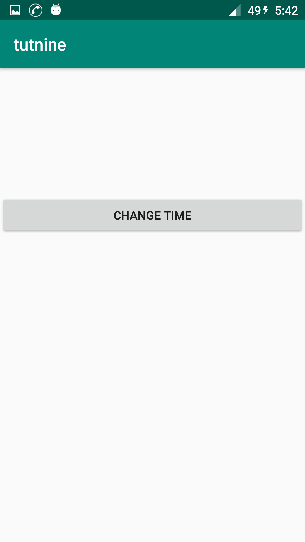
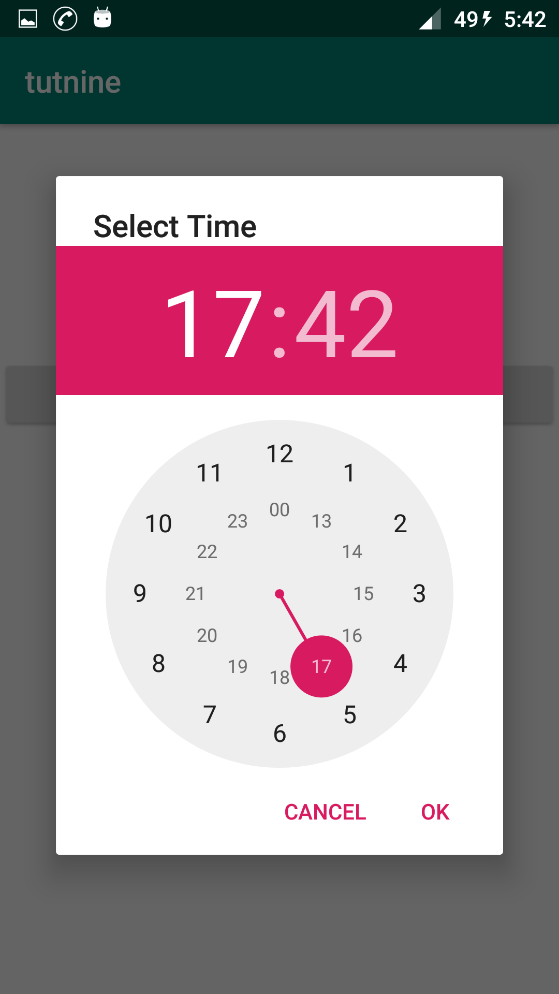
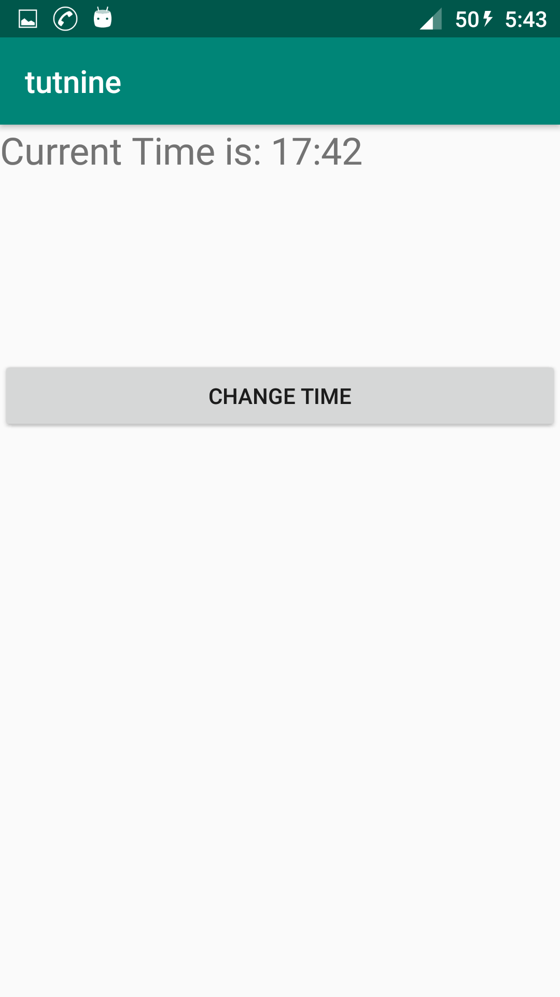

Main_Activity.java

package com.example.warlock.tutnine;
import android.app.TimePickerDialog;
import android.support.v7.app.AppCompatActivity;
import android.os.Bundle;
import android.view.View;
import android.widget.Button;
import android.widget.TextView;
import android.widget.TimePicker;
import java.util.Calendar;
public class MainActivity extends AppCompatActivity {
Button changetime;
TextView disptime;
@Override
protected void onCreate(Bundle savedInstanceState) {
super.onCreate(savedInstanceState);
setContentView(R.layout.activity_main);
changetime=(Button)findViewById(R.id.button);
disptime=(TextView)findViewById(R.id.disptime);
changetime.setOnClickListener(new View.OnClickListener() {
@Override
public void onClick(View v) {
Calendar mcurrentTime = Calendar.getInstance();
int hour = mcurrentTime.get(Calendar.HOUR_OF_DAY);
int minute = mcurrentTime.get(Calendar.MINUTE);
TimePickerDialog mTimePicker;
mTimePicker = new TimePickerDialog(MainActivity.this, new TimePickerDialog.OnTimeSetListener() {
@Override
public void onTimeSet(TimePicker timePicker, int selectedHour, int selectedMinute) {
disptime.setText( "Current Time is: "+selectedHour + ":" + selectedMinute);
}
}, hour, minute, true);//Yes 24 hour time
mTimePicker.setTitle("Select Time");
mTimePicker.show();
// TimePicker has getCurrentHour method, which returns hour in 0-23 format. Thus no AM/PM to display.
}
});
}
}

Activity_main.xml
<?xml version="1.0" encoding="utf-8"?>
<LinearLayout xmlns:android="http://schemas.android.com/apk/res/android"
xmlns:app="http://schemas.android.com/apk/res-auto"
xmlns:tools="http://schemas.android.com/tools"
android:layout_width="match_parent"
android:layout_height="match_parent"
android:orientation="vertical"
tools:context=".MainActivity">
<TextView
android:id="@+id/disptime"
android:layout_width="fill_parent"
android:layout_height="150dp"
android:textSize="24sp" />
<Button
android:id="@+id/button"
android:layout_width="match_parent"
android:layout_height="wrap_content"
android:text="Change Time" />
</LinearLayout>

10. Create a datepicker application where we have to pick current date and display it on the screen.
1. GOPIKA PRADEEP ( 12/04/19)
2. ALFIN WILLIAM ( 05/04/19)
3. ADVAITA MANOHAR ( 12/04/19)
4. GOKUL K ( 05/04/19)

Screenshots:

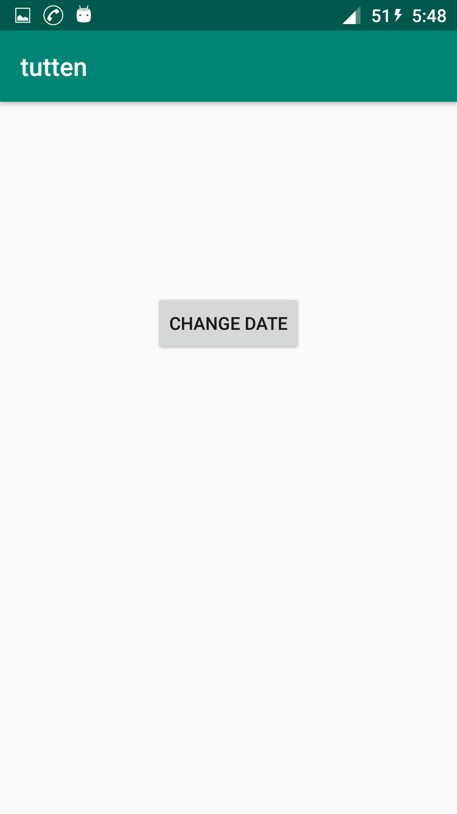
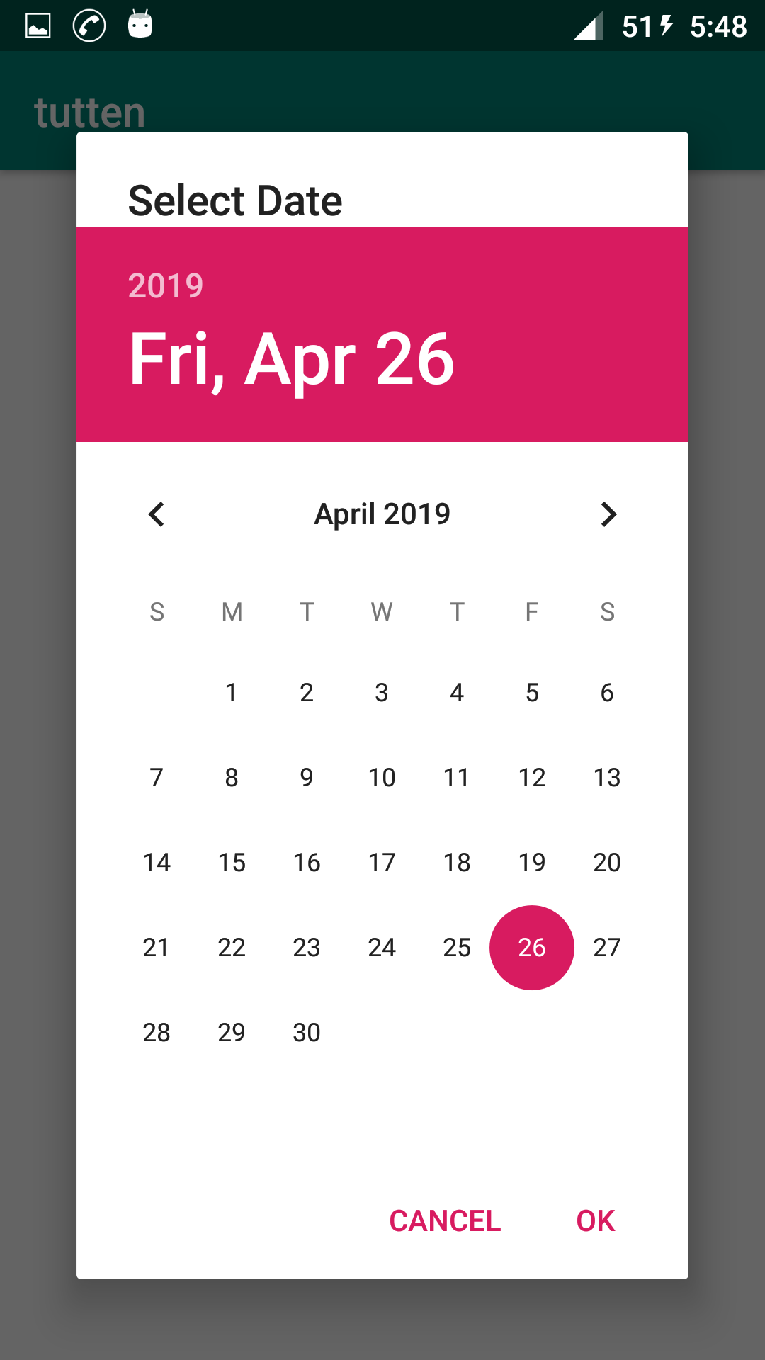
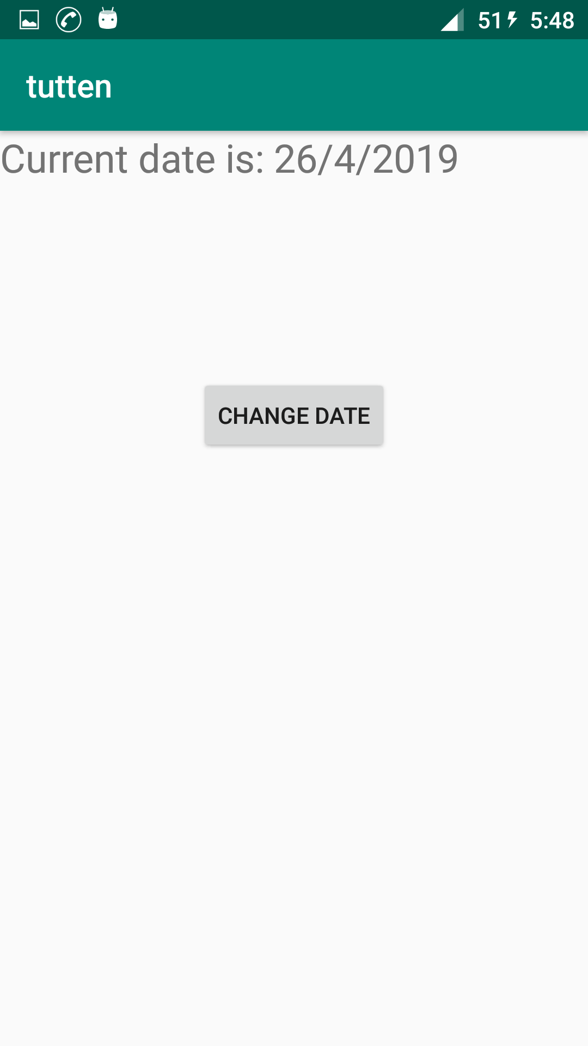

Main_Activity.java
package com.example.warlock.tutten;
import android.app.DatePickerDialog;
import android.support.v7.app.AppCompatActivity;
import android.os.Bundle;
import android.view.View;
import android.widget.Button;
import android.widget.DatePicker;
import android.widget.TextView;
import java.util.Calendar;
public class MainActivity extends AppCompatActivity {
Button changed;
TextView showdate;
@Override
protected void onCreate(Bundle savedInstanceState) {
super.onCreate(savedInstanceState);
setContentView(R.layout.activity_main);
changed=(Button)findViewById(R.id.datebtn);
showdate=(TextView)findViewById(R.id.shwdate);
changed.setOnClickListener(new View.OnClickListener() {
@Override
public void onClick(View v) {
//To show current date in the datepicker
Calendar mcurrentDate = Calendar.getInstance();
int mYear = mcurrentDate.get(Calendar.YEAR);
int mMonth = mcurrentDate.get(Calendar.MONTH);
int mDay = mcurrentDate.get(Calendar.DAY_OF_MONTH);
DatePickerDialog mDatePicker;
mDatePicker = new DatePickerDialog(MainActivity.this, new DatePickerDialog.OnDateSetListener() {
public void onDateSet(DatePicker datepicker, int selectedyear, int selectedmonth, int selectedday) {
// TODO Auto-generated method stub
/* Your code to get date and time */
selectedmonth = selectedmonth + 1;
showdate.setText("Current date is: " + selectedday + "/" + selectedmonth + "/" + selectedyear);
}
}, mYear, mMonth, mDay);
mDatePicker.setTitle("Select Date");
mDatePicker.show();
}
});
}}

Activity_main.xml
<?xml version="1.0" encoding="utf-8"?>
<LinearLayout xmlns:android="http://schemas.android.com/apk/res/android"
xmlns:app="http://schemas.android.com/apk/res-auto"
xmlns:tools="http://schemas.android.com/tools"
android:layout_width="match_parent"
android:layout_height="match_parent"
android:orientation="vertical"
tools:context=".MainActivity">
<TextView
android:id="@+id/shwdate"
android:layout_width="match_parent"
android:layout_height="150dp"
android:textSize="24sp"/>
<Button
android:id="@+id/datebtn"
android:layout_width="wrap_content"
android:layout_height="wrap_content"
android:text="Change Date"
android:layout_gravity="center_horizontal"/>
</LinearLayout>

